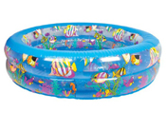

Small kids love to swim in hot summer. This is a unique and beautiful swimming pool for your kid.

Blue color with fishes is a new style for this summer.

Product: Kids Swimming Pool

Price: 1700 PKR

CONTACT US: Address: Aptech Metro Star Gate Karachi

Email: feedback@aptech-education.com.pk